# React native documentation for day 1

<https://www.codecademy.com/articles/react-setup-i>

This is the Link of where I found out how to install react native on a project folder, which will have all the latest modules. <https://reactjs.org> is where I will find any documentation on the latest news and changes that react has to offer us, including the latest update to the software with the recent software.

## Node js, npm, react

So… before all of this could have been possible I had to install node js on my computer (<https://nodejs.org/en/>) it is a quick install, I gets you everything you need including “npm” which is a tool that helps me install react on my folder. In easier words it is a command that you run to install react easily on your folder.

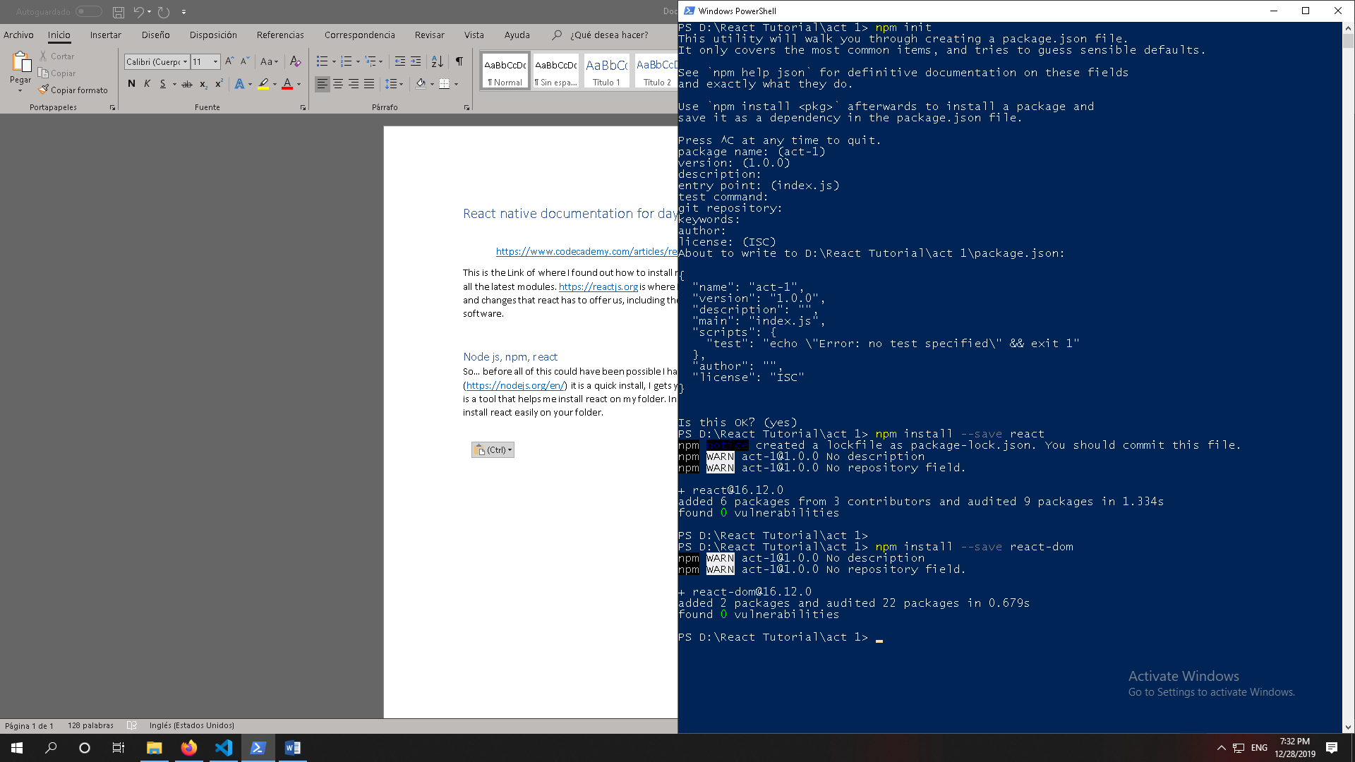

With those commands you are able to run the installation scripts to get the modules and dependencies you will need for your react project.